1. Let’s take time to explore our **Questioning Habits** a little further.
2. When you think about it, the **Word Question** is made up mostly of the **Word Quest** which means **to search for and find meaning**.
3. **One of our challenges** is that we adopt **one of two really fundamental questioning strategies**.
   1. Strategy of Legitimate Questions.
   2. Strategy of Disguised Questions.
4. **Legitimate Questions**:
   1. These are true questions.
   2. They are questions that seek to find an answer, idea, or a solution or understanding.
5. **Disguised Questions**:
   1. **Disguised question** is where we actually **a statement** and we communicate our intention/thoughts/feelings but we then disguise that in the form of question. So, it feels like we are asking somebody when in actual fact, we’re really making an effort to tell them.
   2. **Disguised Questions Examples**:  
        
        
        
        
        
        
        
        
        
        
        
      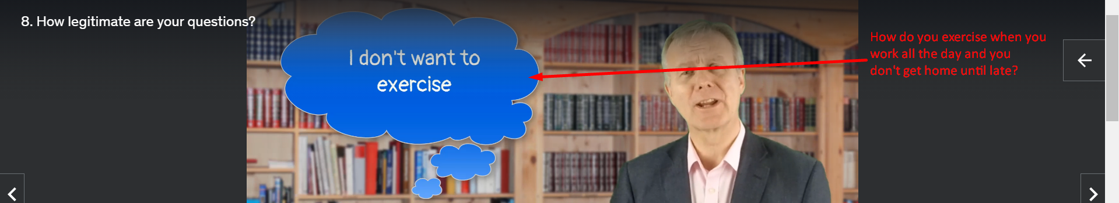  
      So **Disguised Questions** are **Statements** that are **disguised as questions** and we are aiming, either deliberately to manipulate people or more subconsciously just to get our view heard **by including those statements in the form of a question** and hoping that the other person won’t notice that we are telling rather than asking.  
      But a lotta people will see through that.